||JAI SRI GURUDEV||
S.J.C. Institute of Technology, Chickballapur.
Department of Artificial Intelligence and Data Science
TUTORIALS -II
Subject Name & Code: Analysis & Design of Algorithms BCS401

Semester: IV DATE: 22/05/2024

- Design an insertion sort algorithm and obtain its time complexity. Apply insertion sort
on these elements. 25,75,40,10,20.
- Appy exhaustive search method to solve the following instance of knapsack problem
M=40, n=3, w1,w2,w3=(20,25,10) and p1,p2,p3=(30,40,45).
- Apply topological sort on the following graph using source removal and DFS based methods.
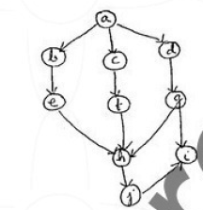
- Apply Quick sort algorithm to sort the list of characters: PROGRAMMING. Draw the tree of recursive calls made while tracing.
- Discuss the General method of divide and conquer along with control abstraction.
- Write algorithm for MergeSort. Also demonstrate the applicability of Substitution method to compute time complexity of merge sort.
- Multiply two numbers a=1234 & b=5678 using divide and conquer method and analyze its performance.
- Apply Strassen’s multiplication to multiply the following matrices. Show the details of the computation and analyze its performance.
A= $\begin{matrix}4 & 5 \\ 1 & 3\end{matrix}$ B= $\begin{matrix}0 & 2 \\ 1 & 3\end{matrix}$
- Write a quick sort algorithm for sort the elements and Analysis its average case performance.
- Explain following terms using proper examples
- Heap 2. Complete Binary tree 3. Almost complete Binary tree 4. Levels of tree 5. Depth of the tree 6. Max heap 7. Min heap
And construct heap for the list 50,25,30,70,100,45,80
- Write a algorithm for bottom-up heap and prove the following inequality
$$\sum_{i=h-1}^{0}{2\left(h-i\right)*2^{i}=2(n-\log_{2}\left(n=1\right))}$$
- Define AVL trees and explain its four rotations with example.
- Construct an AVL tree for the items 25, 26, 28, 23, 22, 24 and 27 and trace the algorithm.
- Explain the heap sort, its phases and analysis of heapsort using bottom-up approach and Construct heap sort for following.
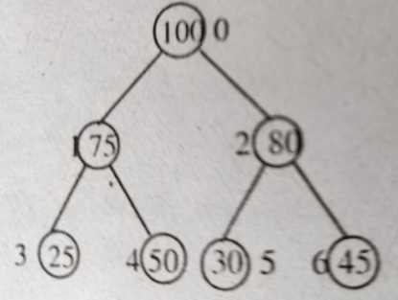
- Write Horspools algorithm for string matching. Apply Horspools algorithm to find
the pattern BARBER in the text: JIM_SAW_ME_IN_A_BARBERSHOP

